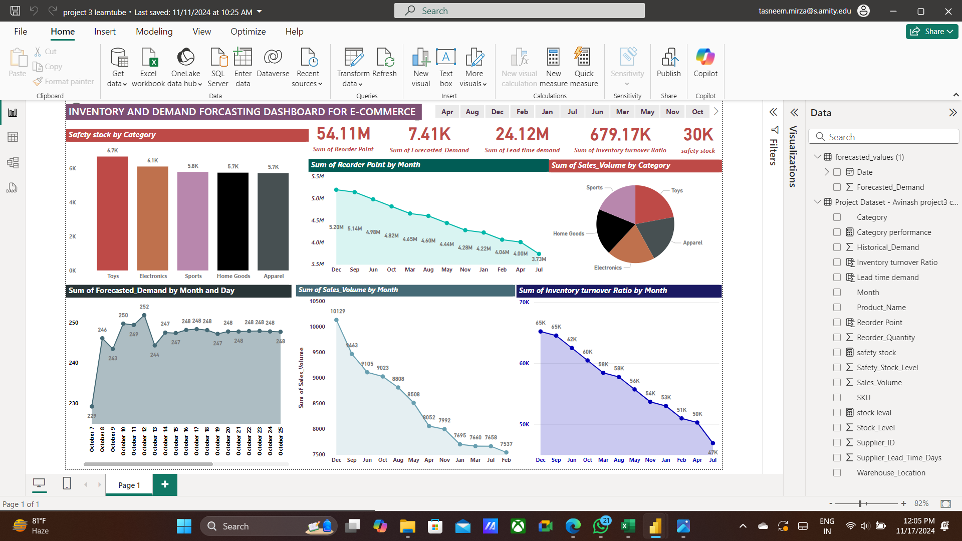

This dashboard is an **Inventory and Demand Forecasting Dashboard for E-commerce**, showcasing key metrics and trends for managing inventory and forecasting demand efficiently. Here's what each visualization shows:

1. **Safety Stock by Category (Bar Chart)**: Displays the safety stock levels across categories like Toys, Electronics, Sports, Home Goods, and Apparel, helping ensure adequate inventory for each category.
2. **KPI Cards**:
   * **Reorder Point (54.11M)**: Total reorder point across all products.
   * **Forecasted Demand (7.41K)**: Anticipated demand based on historical trends.
   * **Lead Time Demand (24.12M)**: Demand during the product lead time.
   * **Inventory Turnover Ratio (679.17K)**: How often inventory is replaced.
   * **Safety Stock (30K)**: Additional stock to prevent stockouts.
3. **Reorder Point by Month (Line Chart)**: Tracks monthly reorder point trends, showing a steady decline, indicating reduced stock replenishment needs over time.
4. **Sales Volume by Category (Pie Chart)**: Proportion of sales volume by product categories, offering insights into which categories are driving sales.
5. **Forecasted Demand by Month and Day (Line Chart)**: Predicts daily demand within a month, ensuring better planning for peak and low-demand days.
6. **Sales Volume by Month (Line Chart)**: Highlights monthly sales trends, peaking in December and gradually declining afterward, indicating seasonal variations.
7. **Inventory Turnover Ratio by Month (Line Chart)**: Shows how efficiently inventory is turning over each month, with a steady decline indicating possible overstocking or slowed sales.

**Key Takeaways:**

This dashboard is a tool for e-commerce inventory management, helping stakeholders balance stock levels, avoid stockouts, optimize reorder points, and forecast demand effectively for different time periods and product categories.